**Chloe Lee_CS 251_WN 23_PE02**

Create a function in R that simplifies the calculation of descriptive statistics. The requirements of the function are as follows:

* The function has three arguments:
* A list of numbers (numeric).
* A letter (character)
* A number (numeric)
* The function behaves as follows
* If the letter is ‘m’, the function prints the arithmetic mean of the list.
* If the letter is ‘v’, the function prints the variance of the list.
* If the letter is ‘s’, the function prints the standard deviation of the list.
* If the letter is ‘z’, the function prints the z-score of num with respect to the list.
* You can use built-in R functions including mean(), var() and sd().

Here is a starting point for the function:

descriptive_function <- function(list, letter, number){

  if(letter == 'm'){

      return(mean(list))

  }

}

Use your function with the built-in rivers data set. You can access the data by typing:

> rivers

Run the following cases (your output should be the same as the one shown):

> descriptive_function(rivers, 'm', 7)

[1] 591.1844

> descriptive_function(rivers, 'm')

[1] 591.1844

> descriptive_function(rivers, 's')

[1] 493.8708

> descriptive_function(rivers, 'v', 8)

[1] 243908.4

> descriptive_function(rivers, 'z', 8)

[1] -1.180844

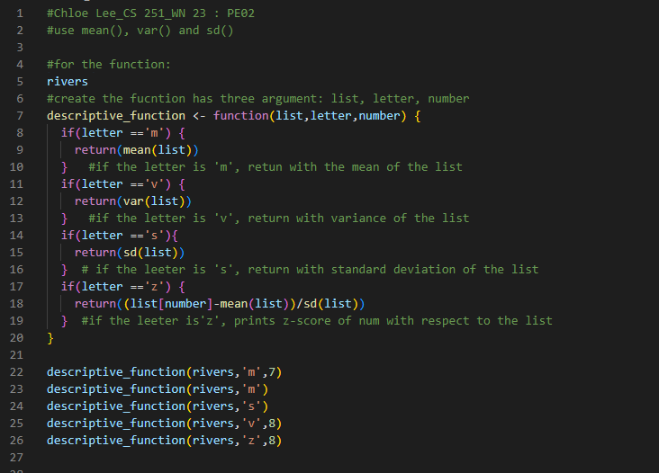

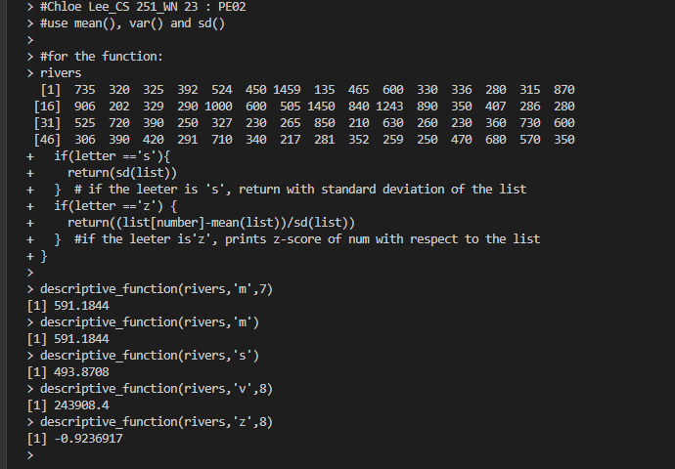

Since the z-score values are different with above output, I ran the z-score to rivers[10], still I am getting same issue that says z-score value for descriptive_function(rivers,’z’,8) is -0.9236917 per below.

